Geomagnetic effect and the ap Prediction product (G.171)

- Strong geomagnetic storm conditions (G3) were observed on 05-06 November 2023 following the arrival of a CME.

Coronal mass ejection: A CME was seen as a partial halo on 03 Novemberat 05:48 UT. The eruption was possibly associated with the corresponding long duration C3.2-solar class flare peaking on 03 November at 06:17 UT. This CME was expected to reach Earth on 06 November between at 06:56 UT and at 16:05 UT according to Effective Acceleration Model (EAM) predictions. The actual shock arrival of this CME was noticed 05 November at 11:45 UT ( CME Scoreboard (nasa.gov)).

Geophysical activity due to CME observed on 05 November 2023:
The solar wind speed reached a peak of 530 Km/s on 05 November at 22:25 UT.
The maximum southward component of Bz reached 37 nT on 05 November at 11:45 UT (http://www.swpc.noaa.gov/products/real-time-solar-wind).
The Dst index reached a peak of -165 nT on 05 November at 20:00 UT.
(Real-time (Quicklook) Dst Index Monthly Plot and Table (kyoto-u.ac.jp)). The geomagnetic field reached at strong geomagnetic storm G3 levels on 05 November (Figure 1).
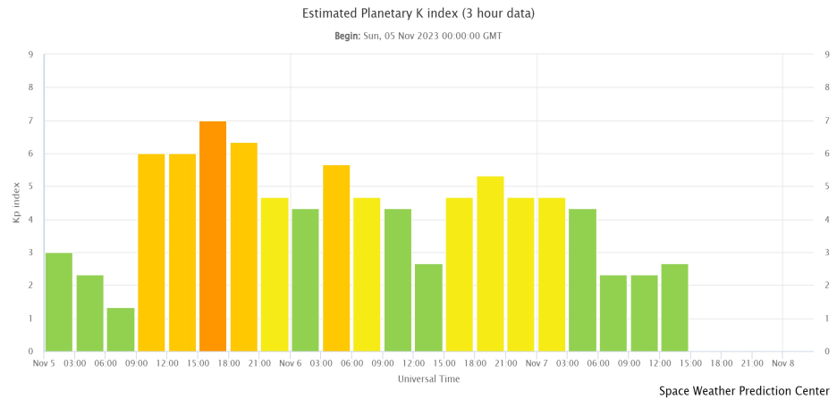
Figure 1: Planetary K index (Planetary K-index | NOAA / NWS Space Weather Prediction Center).
The K_{P} index took the max value 7⁰ on 05 November at 15:00-18:00 UT, then the index a_{p} corresponded to the value a_{pmax} = 132. The daily value of index Ap was equal to 62 on 05 November (International Service of Geomagnetic Indices (gfz-potsdam.de).

- The ap Prediction tool (G.171)

After the CME which observed on 03 November, the forecaster of the Cosmic Ray group/NKUA updated the file: “CME_CH_data.csv” of the ap prediction tool with the following information:
‘2023,11,05,21,00,56,3’. This information indicates that the max level of the ap index was expected on 05 November 2023 at 21:00 UT according to the EAM model for the arrival time of the CME. Also the value of the ap max was expected to be 56 and the index time which defines the time profile for the duration of this event, was given as i=3. The output from the tool with the prediction for the arrival of the CME is presented on Figure 2.

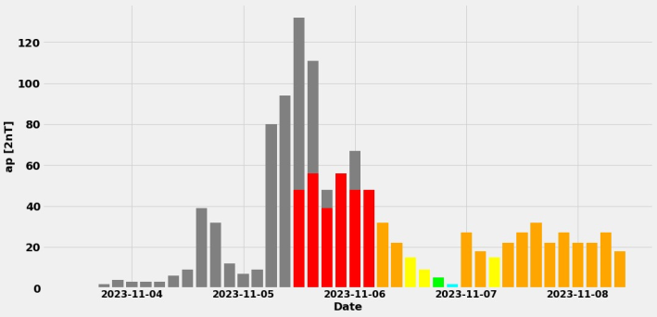

Figure 2. The ap Prediction result (G.171) during the geomagnetic effect.

The ap index got a max value equal to 132 on 05 November 2023 at 15:00 – 18:00 UT according to actual data of GFZ (http://www-app3.gfz-potsdam.de/kp_index/qlyymm.html). As a result the ap tool predicted the geomagnetic storm, but in a lower level and with a time difference of 3 hours.

